

**3PC Screwed FCS Ball Valve** (Three Pc. Design, Regular Port, Screwed End Lever Operated)

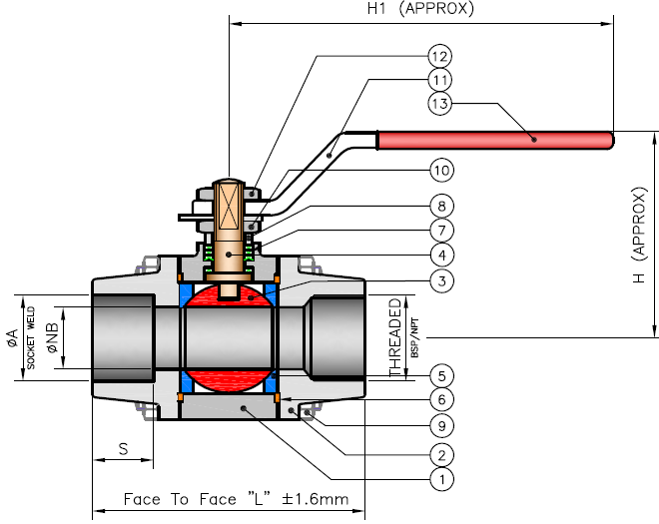

**Features: -**

* Pressure Rating : 800#
* End Connection : SE / SW
* Screwed : ASME B 1.20.1
* Socket Weld End: ANSI B 16.11

**Testing Standard: - BS EN 12266 I / API 607**

|  |  |  |
| --- | --- | --- |
| Test Pressure in PSIG | | |
| Test | Hydrostatic | Air |
| Pr. Rating | 800# |
| Body | 3000 (211 Kg/Cm2) |  |
| Seat | 2000 (141 Kg/Cm2) | 80 |

**Part List: - Standard:- Design Std. BS 5159 800#**

|  |  |  |
| --- | --- | --- |
| **No.** | **Part Name** | **Materials** |
| 01 | Body | A 105  A 182 F 304/304L/316/316L |
| 02 | Side Piece |
| 03 | Ball | AISI 304 / 316 / 304L / 316L |
| 04 | Stem | AISI 304 / 316 / 304L / 316L |
| 05 | Ball Seat | PTFE / GFT / CFT |
| 06 | Body Seal | PTFE / GFT / CFT |
| 07 | Gland Seal | PTFE / GFT / CFT |
| 08 | Gland Bush | AISI 304 / 316 / 304L / 316L |
| 09 | Stud & Nut | A 193 Gr. B7 / 2H / SS |
| 09 | Gland Nut | CS / SS |
| 10 | Hand Lever | CS / SS |
| 11 | Hand Lever Nut | CS / SS |
| 12 | Lever Sleeve | PVC |

|  |  |  |  |  |  |  |  |  |
| --- | --- | --- | --- | --- | --- | --- | --- | --- |
| **SIZE** | **15** | **20** | **25** | **40** | **50** |  |  |  |
| **L** | 67 | 73 | 95 | 116 | 128 |  |  |  |
| **A** | 22 | 27 | 34 | 49 | 61 |  |  |  |
| **NB** | 9 | 13 | 20 | 29 | 37 |  |  |  |
| **S** | 10 | 13 | 13 | 13 | 16 |  |  |  |
| **H** | 50 | 55 | 60 | 80 | 88 |  |  |  |
| **H1** | 130 | 130 | 150 | 180 | 180 |  |  |  |
|  |  |  |  |  |  |  |  |  |
|  |  |  |  |  |  |  |  |  |
|  |  |  |  |  |  |  |  |  |
|  |  |  |  |  |  |  |  |  |
|  |  |  |  |  |  |  |  |  |
|  |  |  |  |  |  |  |  |  |

**Due to continuous development Program, the design & data given in this leaflet are subject to change without prior notice.**

**ANITA ENGINEERING WORKS**



58-59, Narayan Estate, Opp. Shree Ram Estate, Nr. CMC Ltd. Odhav, Ahmedabad-382415, Gujarat, India

Phone: +91 79 22974101, Fax: +91 79 22875014

Email: eascovalves@gmail.com, eascovalves@yahoo.com, Web: [www.eascovalve.com](http://www.eascovalve.com)